HCI and Interaction Design
interaction design: design of interactive products to support the way people communicate and interact in their everyday and working lives (user product, task product, context use of product)
user-centered design: involves users throughout the design process

USABILITY GOALS:
- effectiveness: how good at doing what it has to do
- efficiency: how much support when user carries out task
- safety: protect user from dangerous/undesirable conditions (prevention & recovery)
- utility: provide the right kind of functionality
- learnability: easy to learn to use the system
- memorability: easy to remember how to use the system once learned
user experience goals: enjoyable, helpful, motivating, satisfying, …. (more subjective than usability goals)

DOUBLE DIAMAND DESIGN PROCESS
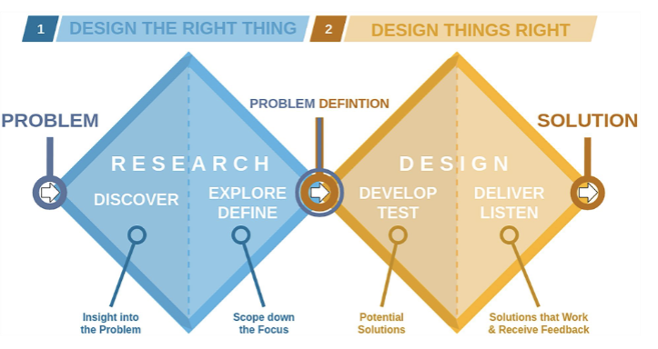
1. Discover: designers seek to understand the problem space by researching and empathizing with users. This involves gathering insights, identifying challenges, and defining the problem from various perspectives.
2. Explore/Define: define a specific problem statement based on the insights gained during the discovery phase. This stage involves synthesizing information, framing the problem, and establishing a clear design challenge to address.
3. Develop/Test: explore a wide range of ideas and solutions in response to the defined problem. This phase encourages creativity and brainstorming to generate a multitude of concepts.
4. Deliver: refine and prototype the chosen solution. This phase involves testing and iterating on prototypes, ensuring that the final product or solution is user-centred and effective.
INTERACTION TYPES:
- instructing: instructions to a system (commands, menu)
- conversing: two-way communication (ticket booking, help system)
- manipulating: interact similar way as physical real-world objects (games, 3d design applications)
- exploring: explore environment by exploiting knowledge of how to navigate
through existing spaces

4 APPROACHES TO INTERACTION DESIGN:
- user-centred design (UCD): translate user needs into design solutions
- activity-centred design (ACD): focus on user behaviour
- system design: system centre of attention, user set goal of the system
- genius design: relies on designer, user validates design

USER INVOLVEMENT:
- importance:
- guarantees user activities taken into account
- expectations management: keep user expectation realistic (pre-release, hands-on demonstration)
- sense of ownership: user involvement → feeling of contribution → more likely to support
- customer support and error reporting systems after product release
- too much user involvement:
- higher cost
- less innovation
- lower team effectiveness
- greater “demands” late into development, …

3 user-centred design principles:
- Early focus on users and tasks: study the users
- design to support behaviours and context of use
- characteristic → take cognitive/physical limitations into account
- Empirical measurement: identify specific usability and user experience goals (sketches, description in natural language and prototypes → see reaction users
- Iterative design: problems identified in user testing fixed and evaluated in next iteration
USER CATEGORIES:
- primary users: frequent hands-on users
- secondary users: occasional users or use through an intermediary
- tertiary users: affected by the introduction of the product or influence its purchase

LIFECYCLE MODEL:
Interaction Design Process (4):
1. Establishing requirements (target users and required support)
2. Designing alternatives (conceptual, physical): consider alternatives (not just what is good enough), discuss with other designers, study other designs, brainstorming sessions, …
3. Prototyping the alternatives (paper, software)
4. Evaluating (determining the usability and acceptability, observing or talking to users, interviews or questionnaires)
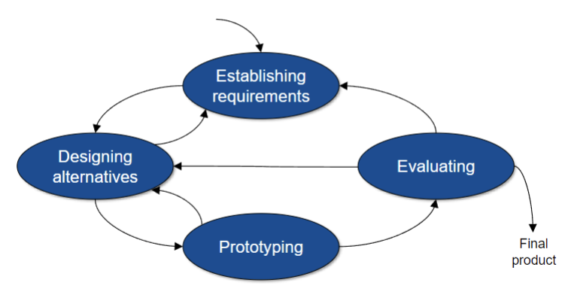

Requirements Analysis and Prototyping
TYPES OF REQUIREMENTS:
- functional requirements: what should it do
- data requirements: type, amount, accuracy
- environmental requirements (context of use):
- physical (lighting, noise, movement, …)
- social (sharing of data, co-located, distributed, …)
- organisational (user support, management hierarchy, …)
- technical environment (hardware capabilities, compatibility, …)
- user charactersistics : skills, background, preferences, disabilities, level of expertise
- usability goals: define objective measure of a user’s performance
- user experience goals

DIFFERENT FORMS OF DATA GATHERING (FOR REQUIREMENTS):
- interviews
- focus groups (opinions within social context, community issues)
- questionnaires
- direct observation
- indirect observation
- studying documentation (manuals, …)
- researching similar products

Interview types:
- open-ended/unstructured: exploratory, rich data, time consuming to analyse
- structured: closed questions: easy to analyse
- semi-structured: combination

PROTOTYPING:
- Low-fidelity (simple, cheap, quick to modify, different from final product, limited functionality): storyboarding (with scenario), sketching, PowerPoint
- high-fidelity (looks more like final product, expensive, time-consuming): fully interactive, often with specialized software
- horizontal: wide range of functions, little detail
- vertical: a lot of details for a few functions
- throwaway: final product built from scratch (no testing necessary along the way)
- evolutionary: prototype evolves into final product (rigorous testing necessary along the way)

HUMAN PERCEPTION AND COGNITION
MODALITY: type of communication channel used to convey or acquire information
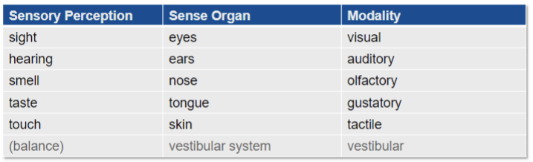
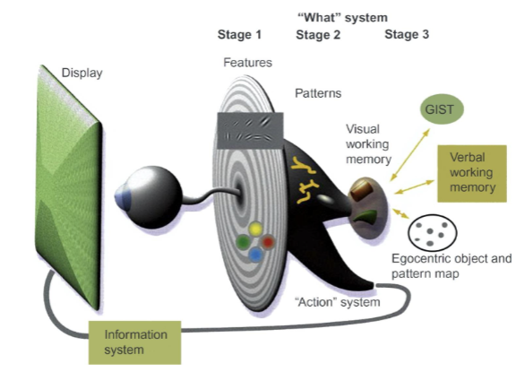
3 STAGES OF THE MODEL OF PERCEPTUAL PROCESSING:
- Parallel processing to extract low-level features: neurons working in parallel, observing orientation, colour, texture, motion
- Pattern perception: slower serial processing, continuous contours, color blocks and textures
- Visual working memory: only a few objects in visual working memory (may provide answers to visual query)
Attention affects all three stages!

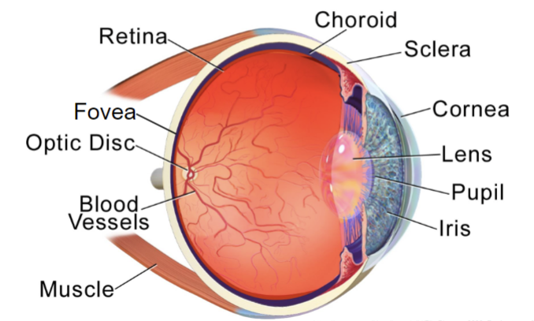
3 BELANGRIJKE DELEN VAN HET OOG:
- lens: adjusting focus of light entering the eye, allowing clear vision at various distances
- pupil: regulate the amount of light entering the eye
- retina: receive and process light, converting it into neural signals that are sent to the brain for visual interpretation

- colour blindness: from of colour vision deficiency (most commonly red-green)

Perception of the world is not an exactly what IS there, heavily biased by:
- past: our experience
- familiar patterns: e.g. do not suddenly switch the order of buttons in an interface
- habituation: e.g. same warning appearing again and again → users will not
bother to read them anymore
- attentional blink: after spotting something important, we are nearly blind to other
visual stimuli for 0.15 to 0.45 seconds
- present: current context
- McGurk Effect: modalities can affect each other (eg. sight can override hearing)
- future: our goals
- cocktail party effect: Things unrelated to our goals seem to be filtered out
preconsciously

GESTALT PRINCIPLES:
- Law of Proximity: items that are closer together appear to be grouped
- Law of Similarity: similar-looking items appear grouped
- Law of Continuity: visually-aligned items are perceived as continuous forms
- Law of Closure: visual system automatically tries to close open figures
- Law of Symmetry (Simplicity): parse complex scenes in a way that reduces complexity
- Law of Figure / Ground: our mind separates the visual field into figure (foreground) and ground (background)
- Law of Common Fate: items that are moved together are perceived as grouped or related
these principles are often used together

DESIGN GUIDELINES AND MODELS
USABILITY HEURISTICS:
- Visibility of system status: keep users informed about what is going on → build up trust
- Match between system and real world: use words/concepts/conventions familiar to the users
- User control and freedom: support undo, redo, exit, cancel, …
- Consistency and standards: ctrl-c, eg shopping cart feature on e-commerce website, …
- Error prevention: design to prevent slips (error sue to inattention) and mistakes (conscious errors based on mismatch of user’s mental model): make risky operations hard to do, prevent permanent errors, …
- Recognition rather than recall: Reduce a user’s memory load by making elements and actions visible: pictures, icons, cues, …
- Flexibility and efficiency of use: keyboard shortcuts and touch gestures, personalisation
- Aesthetic and minimalistic design: focus on essentials on the interface
- Help users recognise, diagnose and recover from errors: clear error messages with description and solution
- Help and documentation: make it easy to search for help

CHANGE BLINDNESS: tendency to only perceive and notice things that match our goal → don’t notice when things change where we aren’t focused.
→ show information where users are already looking at, use visual features/channels that that popout (e.g. blinking) to highlight a change
AFFORDANCE: all possible actions with an object in an environment independent of an individual’s ability to recognize these actions (indications of how an object should be used)
THE NORMAN DOOR: design flaw in doors that makes it unclear or confusing for users to determine whether to push or pull to open the door.

EVALUATION METHODS
3 TYPES OF EVALUATION:
- controlled settings: in labs → usability testing
- reduce outside influence, same instructions → result can be generalised
- natural settings: public places or online → direct observation, interviews
- establish requirements, decide how to introduce product, see product use in real world
- setting without users: heuristics, walkthroughs, analytics, models
DECIDE framework: guide to plan an evaluation study:
- Determine the goals: what do u want to evaluate
- Explore the questions: why wouldn’t people use your product for example
- Choose the evalution methods: based on what type of data u want to collect
- Identify the practical issues: tools needed to carry out evaluation
- Decide how to deal with the ethical issues: develop an informed consent form
- Evaluate, analyse, interpret and present the data: take account of reliability, validity, biases, …

3 stages of heuristic evaluation:
- briefing session
- evaluation period
- debriefing session

GOMS Model:
- Goals: what does the user want to achieve
e.g. find a website
- Operators: cognitive processes and physical actions needed to attain goals
e.g. decide which search engine to use
- Methods: procedure to accomplish the goals
e.g. drag mouse over input field, type in keywords and press the ‘go’ button
- Selection rules: decide which method to select when there is more than one
e.g. press the ‘go’ button or the ‘Enter’ key on the keyboard

- Between-Subjects Design: Compares different groups of participants under separate conditions to analyze group-level effects
- Within-Subjects Design: Involves the same group of participants experiencing multiple conditions to assess individual-level changes.
- Pairwise Design: Focuses on comparing and analyzing differences between specific pairs of conditions or treatments rather than examining all conditions simultaneously.

